Discussion Question:
Implement your own Python code examples to describe how tuples can be useful with loops over lists and dictionaries. Do not copy code from the textbook or any other source. Your descriptions and examples should include: the zip function, the enumerate function, and the items method.
Answer:
Tuples can be useful when working with loops over lists and dictionaries because they are immutable sequences in Python, hence enabling combination of elements and iterate through them efficiently (Downey, 2015). Below are the examples using the zip function, the enumerate function, and the items method.
Zip() function:
The zip() function can used to combines several iterables based on the element then return an iterator of tuples. It is specifically used when iterating over several lists simultaneously (Downey, 2015). See example below:
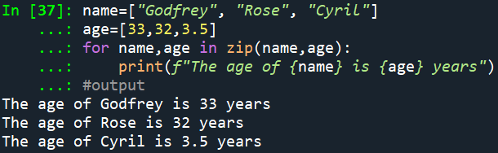
The example above shows how the zip() function has been used to combine name and age list based on their elements into tuples before iterating through the tuples using a loop to print the name and corresponding age.
enumerate() function:
The enumerate() function usually returns an iterator of tuples with the index and the value from an iterable (Downey, 2015). See example below:
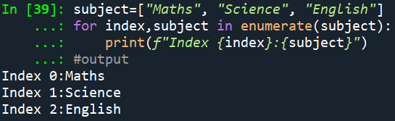
The example above shows how the enumerate() function has been used to returns tuples with the index and subject from the subjects list, which enables looping over the list and access both the index and the subject in each iteration.
items method:
The items() method can be used to returns a view object that provides tuples of key-value pairs in a dictionary. (Downey, 2015). See example below:
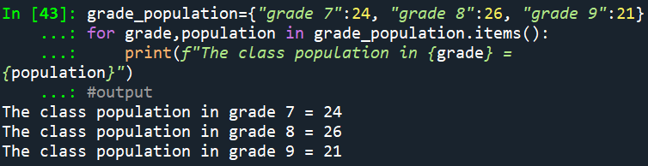
The example above shows how items() has been used to return tuples with the grade and population for each class in the grade_population dictionary. A loop to access both the class and their corresponding score can be used to iterate over these tuples.
Question:
How are items accessed in a dictionary, and what happens when a key is not present in the dictionary?
Reference
Downey, A. (2015). Think Python: How to think like a computer scientist. Green Tree Press.

